Kontaktperson Claudia Zaugg

Telefon 044 723 24 17

E-Mail claudia.zaugg@thalwil.ch

German language survey

- German language skills and language evelopment of your pre-school-aged child with birth date between 1th August 2022 – 31th July 2023

Dear parents and guardians,

The questionnaire is sent to all parents and guardians in the municipality of Thalwil whose children are of preschool age. Thank you for taking the time to complete the questionnaire with your child. Please answer the questions in the way that best reflects your child and your situation. There are no right or wrong answers. All information you provide will, of course, be treated confidentially.
We kindly ask you to return the completed questionnaire to us by 31 March 2026 at the latest. You will then receive your personal results by post.

Abteilung Jugend und Familie Thalwil
Fachstelle Frühe Förderung
Claudia Zaugg
Mühlebachstr. 53
8800 Thalwil
Tel. 044 723 24 17
claudia.zaugg@thalwil.ch

Please complete the following questionnaire:
Child | First name |  | Last name |  |  | Date of Birth
First  parent | First name |  |  | Last name
Second parent | First name |  |  | Last name
Child Adress |  | Street/Number |  |  | Postcode/Place
Phone |  |  | Email:
1. Is German or another language spoken in your family?

☐ German or Swiss German
☐ German and mother tongue in equal parts
☐ rarely German
☐ no German
2. In which language does the
child speak at home?

3. What other  languages does  your child speak  or understand? |  | ☐ No other languages  ☐ The following language(s):
4. What language(s)
does the mother normally speak with the child?
5. What language(s)
does the father normally speak with the child?
6. How do you rate your own German language skills?

Mother: 󠆮 ☐ none ☐ low ☐ medium ☐ (very) good
Father: ☐ none ☐ low ☐ medium ☐ (very) good

7. Does your child understand German (understands but does not yet speak)?
☐ No
☐ Yes, a little
☐ Yes, quite well
☐ Yes, very well
8. Does your child speak German (understands and speaks)?
☐ No
☐ Yes, a little: single words like «Auto», «Hund», «Apfel»
☐ Yes, quite well: simple sentences like «Ball spielen», «ins Bett gehen»
☐ Yes, very well
9. Since when does your child speak German?
☐ It does not speak German yet.
☐ Since a few months.
☐ Since about one year.
☐ Since it could talk.
10. How often does your child say something in German?
(Example: to parents, other children, relatives etc.)
☐ Never
☐ Rarely
☐ Now and then
☐ Often
11. Does your child ask questions in German?
(Example: Wo ist der Ball? Was ist das?)
☐ Never
☐ Rarely
☐ Now and then
☐ Often
12. Does your child understand the following questions in German?

«Wo ist das Fenster?»
☐ Yes ☐ No ☐ I cannot judge that.

«Was ist dein Lieblingsessen?»
☐ Yes ☐ No ☐ I cannot judge that.

«Wie gross bist du?»
☐ Yes ☐ No ☐ I cannot judge that.

«Willst du mitspielen?»
☐ Yes ☐ No ☐ I cannot judge that.

13. Does your child know and speak the following words in German?

What are the children doing Does your child understand and
in the pictures? speak the words next to the pictures?

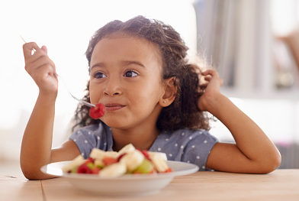
essen Yes ☐ No ☐


schlafen Yes ☐ No ☐


ziehen Yes ☐ No ☐

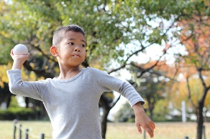
werfen Yes ☐ No ☐


trinken Yes ☐ No ☐


Jacke
anziehen Yes ☐ No ☐

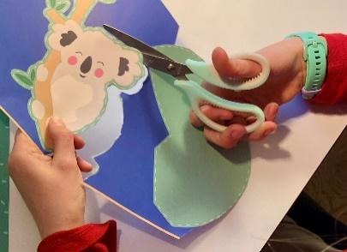
schneiden Yes ☐ No ☐

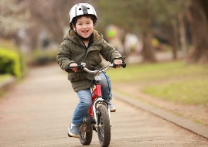
Fahrrad Yes ☐ No ☐
fahren

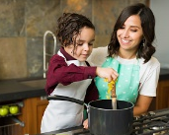
kochen Yes ☐ No ☐


schreiben / Yes ☐ No ☐
zeichnen


rennen Yes ☐ No ☐

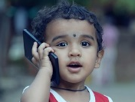
telefonieren Yes ☐ No ☐

14. Does your child currently attend a childcare facility?
☐ No ☐ Daycare ☐ Playgroup ☐ Daycare family ☐ something else

If yes, what language is used in the facility?
☐ German ☐ Other language ☐ German / foreign mixed

Name of childcare facility
Daycare, Playgroup, Daycare family or other

Days per week

☐1x ☐2x ☐3x ☐4x ☐5x

Half days per week
☐1 x¹/₂ ☐2 x¹/₂ ☐3 x¹/₂ ☐4 x¹/₂ ☐5 x¹/₂

15. Comments
Klicken Sie hier, um Text einzugeben.

For specific questions regarding your child please contact Claudia Zaugg on tuesdays or thursdays by phone or via email.

Many thanks for your time and support!
Danke
Obrigado
Spasibo
Hvala

Grazie
Thanks
Faleminderit
Merci

Date
